Part C 1.



By running each data structure as shown in the image above, it is clear that linkedlists are a more efficient structure as it only took 2 milliseconds to add 10,000 objects.

2

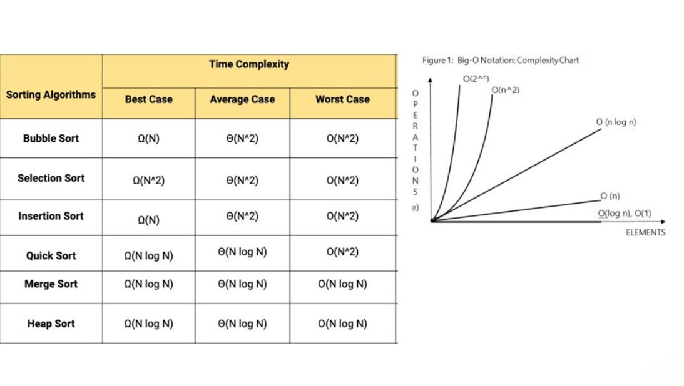

The image above shows that the best sorting method for our use is merge sort as its average and worst case scenarios has the best outcome for a large amount of elements and the fewest operations, followed by insertion sort as its best case is better than both bubble and selection sort although its average and worst case is the same, both bubble and selection sort are equally bad.

Here I will explain how each sort works:

1. Insertion sort works by moving individual elements into the location they belong, this is done starting form the element in the second spot and moving it in front of the first element if it is smaller that it.

2. Merge Sort works by splitting up a list into its elemental parts and then merging two individual parts and arranging them, once completed the pairs are merged with another pair and sort that small list and then merge and sort again until the list is completely sorted. This sort is the quickest option and will work best for a large list like the one used by the team.

3. Bubble Sort works by comparing adjacent items and swapping them if they are out of order, this comparison is run through the entire list again and again until no swaps are done meaning the list is ordered

4. Selection Sort works by finding the smallest value and then putting it to the front, then finding the next smallest and moving it to the front, it continues until all items are sorted.

Source 1: TafeSa

Source2: <https://en.wikipedia.org/wiki/Sorting_algorithm>